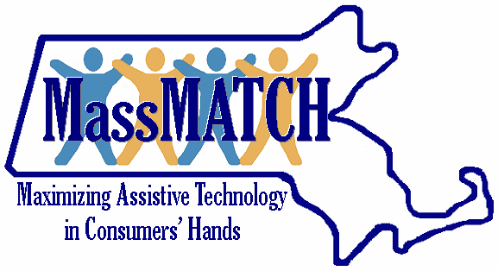

MassMATCH Advisory Council
Membership Nomination Form

Please return this form to MRC. You may send your responses by mail, e-mail or fax; or you can call us and we will complete a form by phone on your behalf. Thank you!

Name: ____________________________________________________________________

Street Address: _____________________________________________________________

City/Town: ______________________ State: ___________ Zip Code: _____________

Email Address: _____________________________________________________________

Phone Number: _______________________□ Voice/ TTY ____________________ Fax

Best day/time to contact you: __________________________________________________

Please help us by answering the confidential questions below:

How did you hear about the Advisory Council?

__________________________________________________________________________

What is it that makes you want to join the Advisory Council?

____________________________________________________________________________________________________________________________________________________

Please tell us about your personal experience with assistive technology, whether for yourself or a family member.

______________________________________________________________________________________________________________________________________________________________________________________________________________________________

Would you be available to attend Advisory Council meetings, in-person or by phone, at least three or four times annually? If your answer is No, how best can you participate/serve?
□ Yes □ No □ Other

The Advisory Council has a number of issue specific committees. Please check those that may interest you:
    - AT in Employment
    - AT in Elementary/Secondary Education
    - AT in Youth Transition
    - AT in Transition from Institutional to Community Living
    - AT in Higher Education
    - Other__________________________________

We are looking for other individuals who could contribute to the Advisory Council. If you would like to nominate someone, please share their contact information with us: ____________________________________________________________________________________________________________________________________________________

REQUIRED COMPOSITION OF THE AT ACT ADVISORY COUNCIL

At least 51% of the members of the Advisory Council must be individuals with disabilities who use assistive technology or the family members or guardians of individuals with disabilities who use AT.

The Advisory Council is also required to include representatives of the MA Rehabilitation Commission (MRC), MA Commission for the Blind (MCB), Independent Living Centers (ILCs), MA Workforce Investment Board (WIB), MA Department of Elementary and Secondary Education (DESE), or other state agencies or private organizations. These appointed members do not count towards the 51% consumer/family majority, even if they have a disability.

Please check which of the following apply to you:

- A person who has a disability and uses AT
- A family member or guardian of a person who has a disability and uses AT
- Other____________________________________________

The Advisory Council must reflect the diversity of Massachusetts with respect to geography, race/ethnicity, gender, age, and type(s) of disability.

Please check ONLY ONE choice in each of the following sections. Use the COMMENTS Section to provide details, as needed. (Please note that the demographic information requested below is not required)

Age
Age 24 or under
Age 25-40
Age 41-59
Age 60 and older

Gender
Female
Male
Prefer not to disclose
Other

Race and Ethnicity
American Indian or Alaska Native
Asian
Black or African American
Native Hawaiian or Other Pacific Islander
White
Hispanic/Latino
Two or More Races
Choose Not to Disclose

Disability (consumer or family rep)
Cognitive
Mental/Emotional
Physical
Hearing
Speech
Vision
Multiple
Other

COMMENTS:

Term length for MassMATCH Advisory Council Members is 3 years, with an option to extend for one additional year. Members of the Advisory Council receive no compensation for their service on the Council but shall be reimbursed for reasonable and necessary expenses related to their membership on the Council.

Signature: ____________________________________ Date_____________________

Please mail, fax, or scan/email completed Nomination Form to:
ATTN: Kobena Bonney, MassMATCH Program Coordinator
Massachusetts Rehabilitation Commission
600 Washington Street, 2nd Floor, Boston, MA 02111
Phone: (617) 204-3826; Fax: (617) 204-3877; Email: info@massmatch.org

For Official Use Only:
Date of Appointment:
Eligibility Start Date:
Term End Date:

